DIYPowerPCB

Introduction
Theoretical derivations in a lecture are part of everyday university life. But you can only really get to grips with topics if you apply what you have learned! For this reason, we have developed the DIY Power PCB. This enables us to provide all interested students with their own hardware platform to carry out a wide variety of experiments on the subject of power electronics.
The idea was not to build the most powerful or the smallest hardware, but a hardware whose components can largely be assembled automatically and which is above all inexpensive and robust. So no worries if a short circuit is generated or smoke rises
The DIY Power PCB is used in various experiments in the lectures on power electronics and electrical drives and costs less than 20€ for our students when fully assembled.
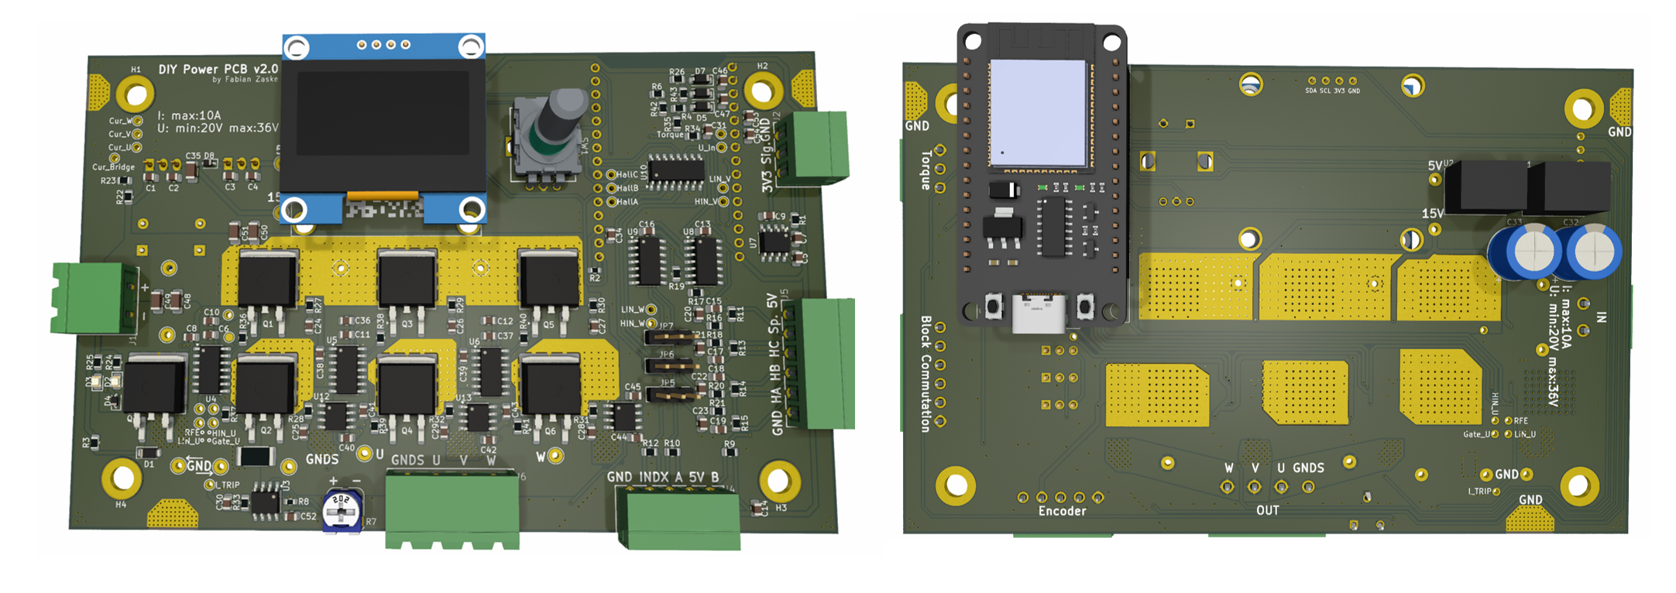
Parameters:
- 3x half bridges
- Adjustable overcurrent shutdown
- ESP32 Wroom microcontroller
- 1.36 OLED display
- Max. 36V @10A input
- Hall sensor or encoder inputs
- General purpose analog input
- Reverse polarity protection
The brain of the board is represented by an ESP32 microcontroller. This controller is very powerful and widely available at affordable prices. You can directly program it using the Arduino IDE or ESP-IDF. For lab lessons, you will use a serial communication interface between MATLAB Simulink and the controller to command the board.
Schematic: schematic_diy_power_pcb.pdf
To use the DIY Power PCB, you can program the ESP32 using the Arduino IDE or the ESPRESSIFWorkspace (Espressif-IDE) development platform. Arduino IDE is more intuitive; however, it is not capable of utilizing the full range of the timer units. Espressif-IDE allows you to access the full functionality of the microcontroller, and the programmer is also faster than the Arduino IDE. However, it is more complicated to get started with.
Board Flyer
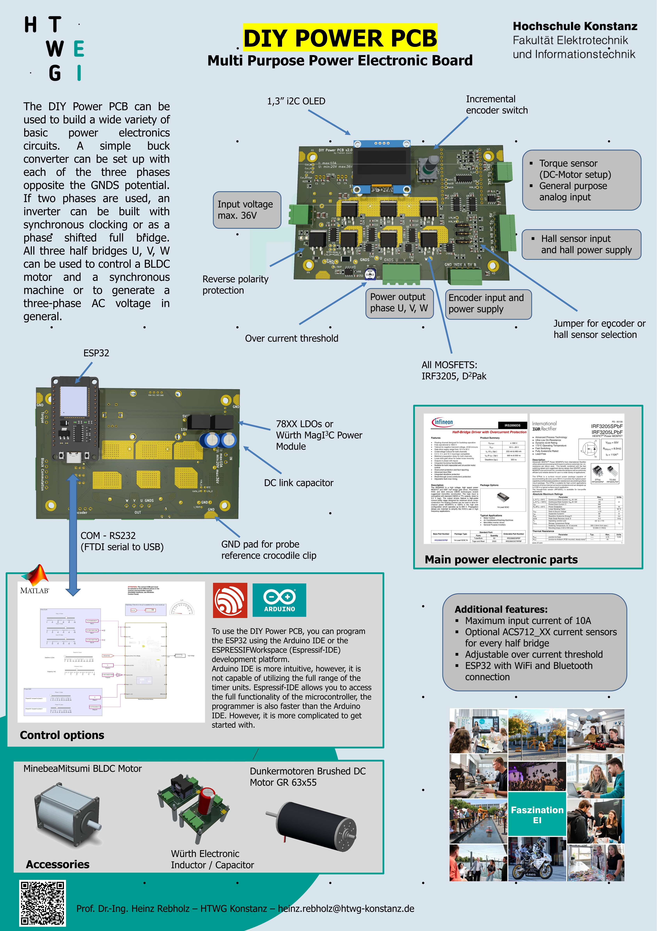

Downloads

Version 2.3
Version 2.3 of DIY Power PCB KiCAD Files: powerpcb_v3.2.1.zip

Version 2.2
Version 2.2 of DIY Power PCB KiCAD Files: Download
Following Bugs will be removed within V3 soon:
- Flashing only works if the incremental encoder is in the correct position, as it blocks the UART signal at every second rotation stage.
- The incremental encoder only works if the ESP32 is also supplied via USB.
- As the internal resistance of the driver is considerably high (200 Ohm), the bootstrap capacitor is only recharged slowly. This means that only duty cycle values of up to approx. 90% are possible. In V3 the problem is solved by an additional external bootstrap diode.

General Information
If you want to generate fancy 3D images you have to download the model files: Download 3D Models
The content of the .zip must be saved in the “3dmodels” folder of KiCAD in a new folder with the name “htwg.3dshapes”.
If your PC does not recognize a USB-to-serial connection, you might not have installed the correct driver yet: Download the latest drivers: Link to FTDI

Isolation
In many of our experiments, we control the hardware via the serial interface. To protect the connected PC, you should use galvanic isolation between the PC and the microcontroller board when the supply voltage is active. This prevents overvoltages from destroying the USB port even in the event of major errors in the setup (short circuit or load dump) on the control PC.
The isolators are available in the laboratory.
z.B.


