Solar Tracker
To get startet with the augmented reality assembly of the SolarTracker, print the QR-Code qr-code_a4_80mm.pdf and open the „Solartracker-HandsOnExperience“ within the Vuforia View App.
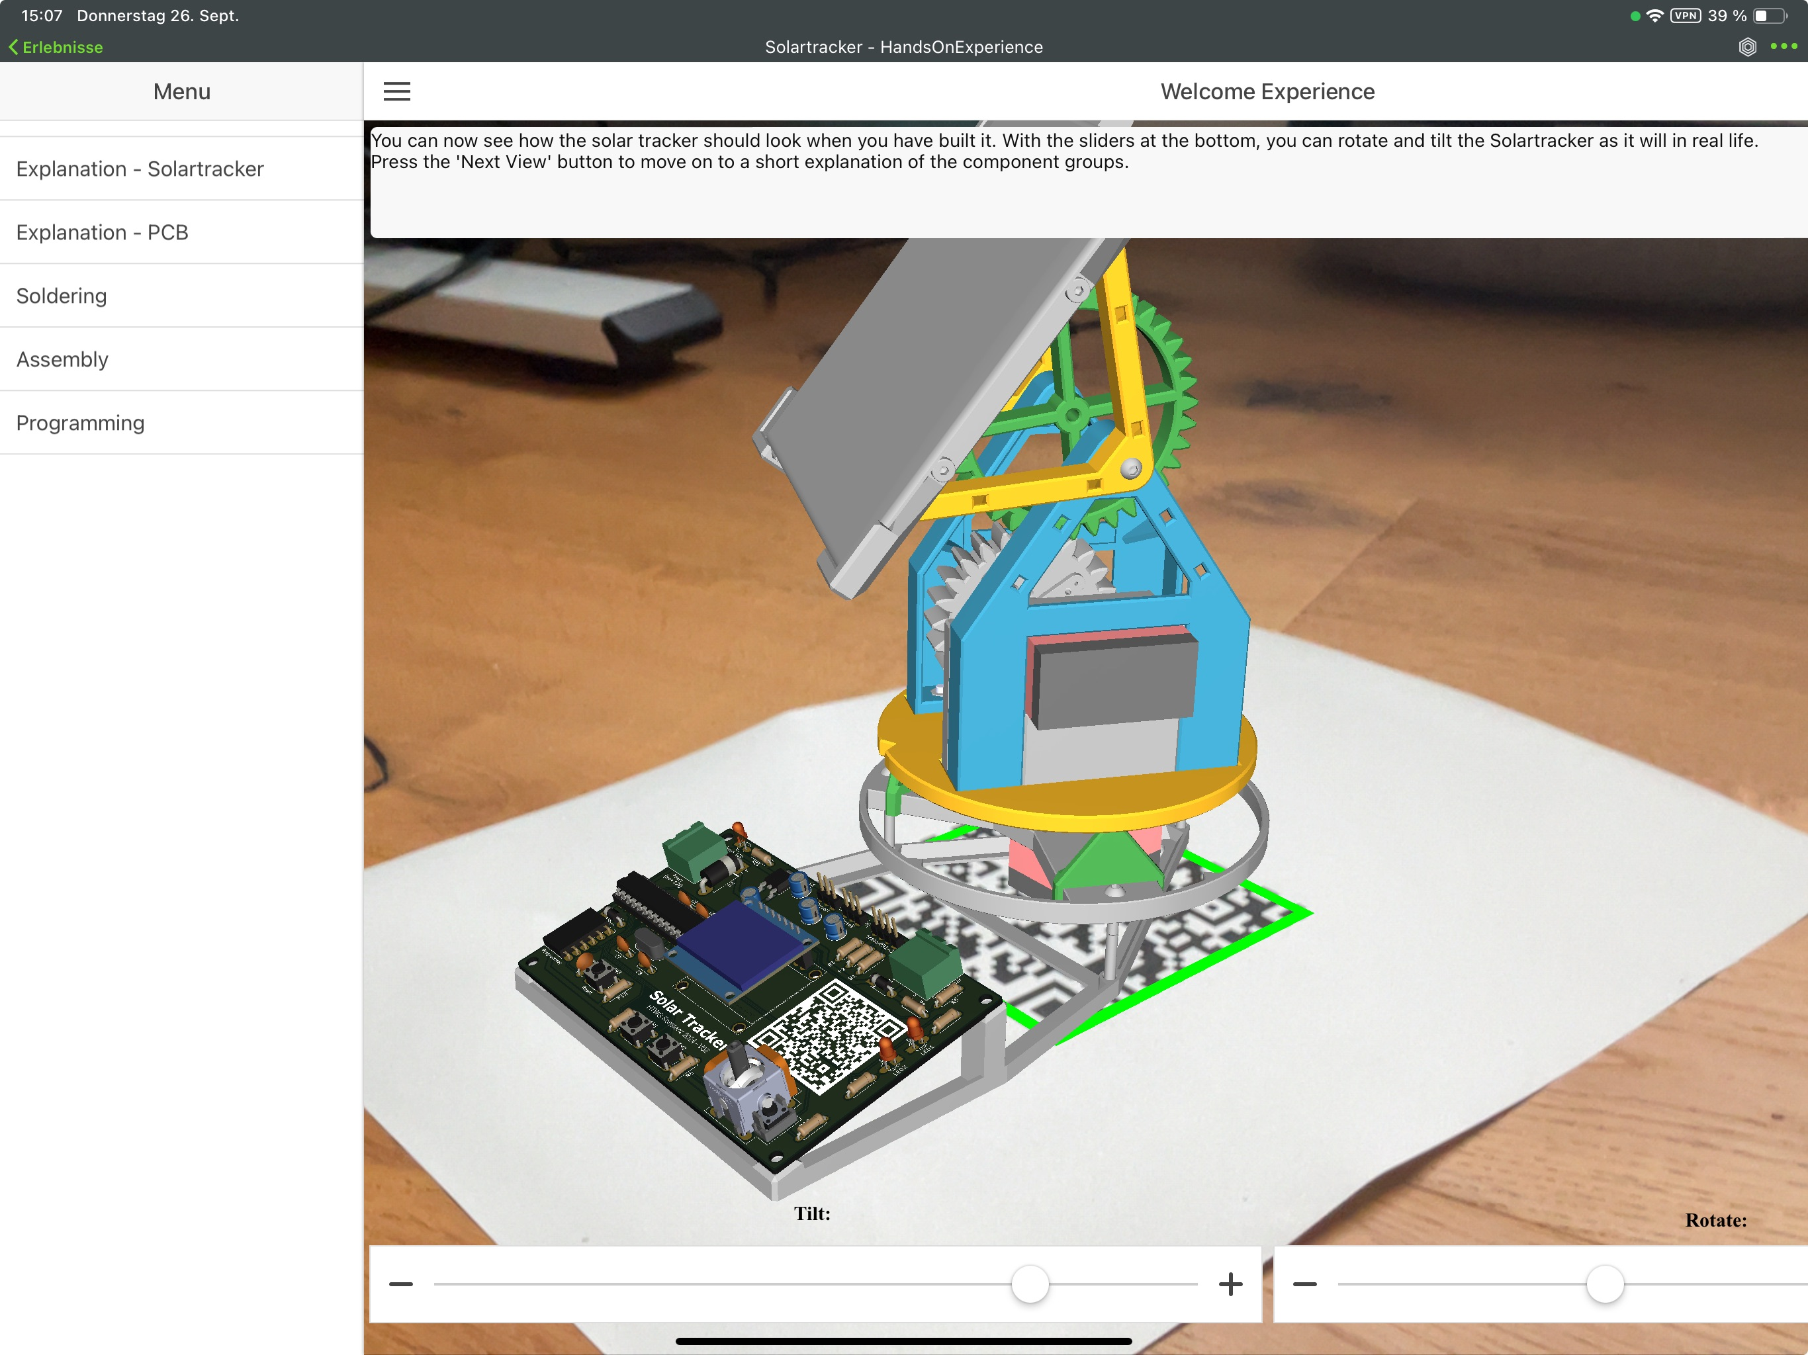
This is the schematic of the PCB:
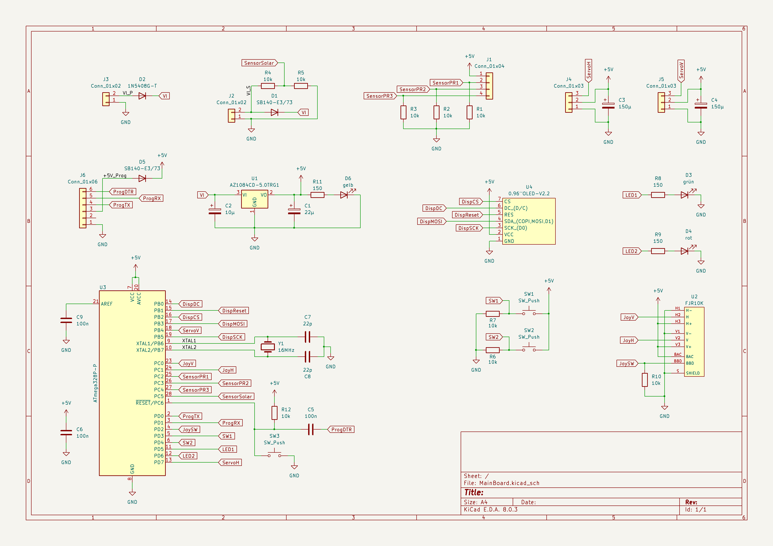
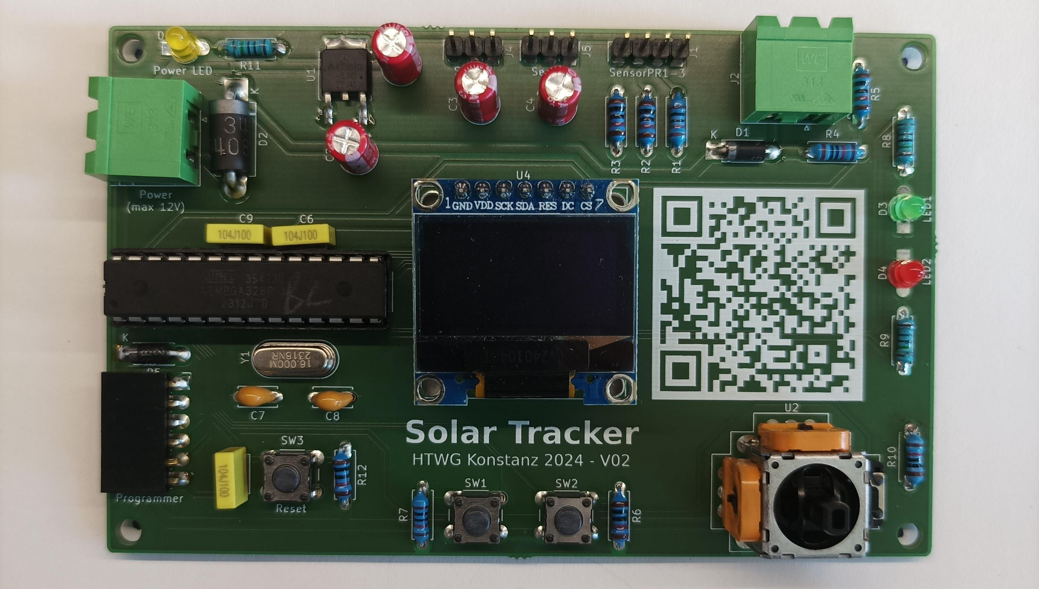
The final board should look like this:
A step by step assembly description of the mecanical part can be found here. (Backup if AR is not working) Tracker Assembly
An interactive BOM (Bill Of Material) can be found here: solartracker_ibom.zip

